Annexure 2.2a : SOP ( Standard Operating Procedure)

- Process of capturing customer’s investment objectives
  - We use a digital Goal creation tool ( SEBI portal), where we capture our customer’s investment objective to provide them with a rough estimate of required savings for their financial Goals. Such tools also help us assign the Risk categorisation to our customer’s. We review our customers Risk status according to the change in their ‘achievement stage’ or change in their Income status etc – like we move them from accumulation stage to transition stage and further to distribution stage etc

- Process of Risk profile
  - We record our customer's Risk profile and categorize them under one of these categories : Conservative, Moderate , Aggressive, and Very Aggressive.
  - We also add the factors captured under investment objective , to finally assign the Risk category to our customers
  - We use this appropriateness principle while executing the customer’s order; we upgrade the Risk degree of the customer if required. Please refer our Risk modification letter in the attachment

- Process of for selection / recommending a MF scheme
  - We do not recommend any scheme beyond the upper limit as mentioned in the table below :

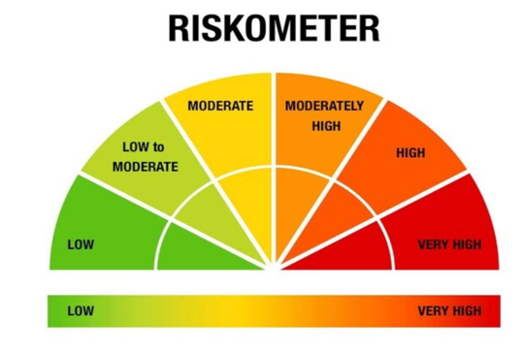

We have set the upper limit for all our Risk categories to identify the unsuitable transactions :

Sl No | Customer’s Risk category | Upper limit of Scheme Type as per Riskometer
1 | Conservative | Upto ‘Moderate’ Risk schemes in Riskometer
2 | Moderate | Upto ‘Moderate High’ Risk schemes in Riskometer
3 | Aggressive | Upto ‘ High’ Risk schemes in Riskometer
4 | Very Aggressive | Upto ‘Very High’ Risk schemes in Riskometer

